**https://www.cienciadedatos.net/documentos/py27-time-series-forecasting-python-scikitlearn.html**

**Multi-Step Time Series Forecasting**

The common objective of working with time series is not only to predict the next element in the series (t+1t+1) but an entire future interval or a point far away in time (t+nt+n). Each prediction jump is known as a step.

There are several strategies that allow generating this type of multiple prediction.

**Recursive multi-step forecasting**

Since to predict the moment tntn the value of tn−1tn−1 is needed, which is unknown, it is necessary to make recursive predictions. New predictions use previous ones as predictors. This process is known as recursive forecasting or recursive multi-step forecasting.

The main adaptation needed to apply [Scikit-learn](https://scikit-learn.org/stable/) models to recursive multi-step forecasting problems is to transform the time series into a matrix in which each value is associated with the time window (lags) preceding it. This forecasting strategy can be easily generated with the ForecasterAutoreg and ForecasterAutoregCustom classes from the **Skforecast** library.

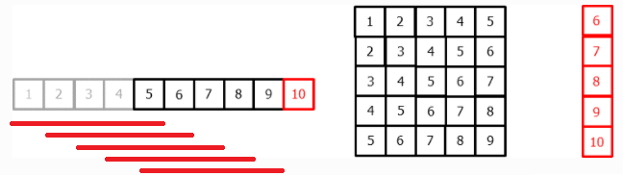

*Transformation of a time series into a 5 lags matrix and a vector with the value of the series that follows each row of the matrix.*

This type of transformation also allows the inclusion of exogenous variables to the time series.

*Transformation of a time series joining an exogenous variable.*

**Direct multi-step forecasting**

The direct multi-step forecasting method consists of training a different model for each step. For example, to predict the following 5 values of a time series, 5 different models are required to be trained, one for each step. As a result, the predictions are independent of each other.

The main complexity of this approach is to generate the correct training matrices for each model. The ForecasterAutoregMultiOutput class of the [**Skforecast**](https://joaquinamatrodrigo.github.io/skforecast/) library automates this process. It is also important to bear in mind that this strategy has a higher computational cost since it requires the train of multiple models. The following diagram shows the process for a case in which the response variable and two exogenous variables are available.

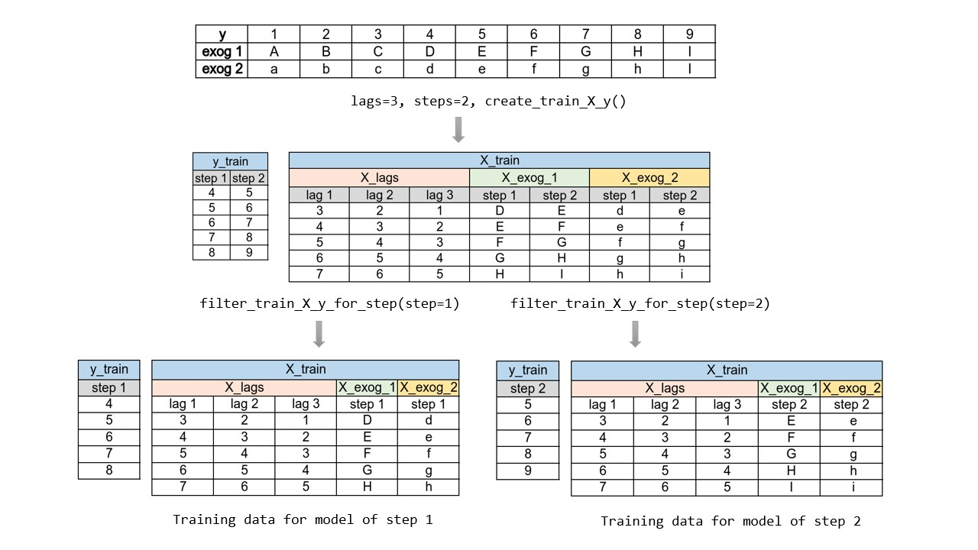

*Transformation of a time series into the necessary matrices to train a direct multi-step forecasting model.*

**Multiple output forecasting**

Certain models are capable of simultaneously predicting several values of a sequence (one-shot). An example of a model with this capability is the LSTM neural network.